Software Requirements Specification (SRS)
Project Name: Library Management System with DevOps Automation
Version: 1.0
Team Members: Sikai Han, Jeremiah Agbebi ,Pritika Pritika, Jakaran Singh

1. Introduction

1.1 Purpose
The purpose of this project is to develop a Library Management System that provides book borrowing, user management, and loan tracking functionalities. The system integrates DevOps automation (CI/CD and monitoring) to ensure continuous delivery and high availability. The intended users include students, teachers (or general readers), and administrators.

1.2 Scope
The system is composed of a frontend (React) and a backend (Flask + SQLite) and offers the following features:
- User registration, login, and role-based access control
- Book management (add, update, delete, search)
- Borrowing and returning operations
- Loan history and status tracking
- CI/CD automated deployment using Jenkins
- System monitoring with Nagios

1.3 Definitions, Acronyms, and Abbreviations
UI: User Interface
API: Application Programming Interface
CI/CD: Continuous Integration / Continuous Delivery
DevOps: Development and Operations

1.4 References
- IEEE SRS Standards
- Student Knowledge Testing Website SRS
- Library System with DevOps Automation

2. Overall Description

2.1 Product Perspective
The Library Management System is a standalone web application accessible from modern browsers. It provides core library functions while integrating DevOps practices for continuous delivery and monitoring. Future versions may extend support to multi-institution use.

2.2 Product Features
- Book management (CRUD operations)
- User management with authentication and authorization
- Borrowing and returning of books
- Loan and status tracking
- CI/CD pipeline for automated builds, testing, and deployment
- Real-time monitoring and alerting with Nagios

2.3 User Classes and Characteristics
- Students/Readers: Can search, borrow, and return books.
- Administrators: Can manage users, books, and loans.
- Developers/Operators: Maintain system deployment and monitoring.

2.4 Operating Environment
- Frontend: React (Vite build)
- Backend: Flask with SQLite
- CI/CD: Jenkins
- Monitoring: Nagios
- Supported Browsers: Chrome, Firefox, Edge, Safari

2.5 Constraints
- Must ensure secure authentication and data handling
- Compliance with privacy regulations
- Operates under limited resources (SQLite as DB)

2.6 Assumptions and Dependencies
- Users have stable internet access
- Jenkins and Nagios servers are properly configured
- Basic computer literacy of end-users

3. System Features
The system is divided into four main work packages, each assigned to one team member.

3.1 Frontend Development (Pritika)
Feature: User Interface for Library System
Description: Build React-based frontend for browsing, searching, borrowing books.
Inputs/Outputs: User input via forms, output via rendered UI.
Priority: High
Dependencies: Backend API availability.

3.2 Backend Development (Sikai)
Feature: Flask-based REST API with SQLite database
Description: Manage books, users, and loans; handle authentication.
Inputs/Outputs: API requests/responses (JSON).
Priority: High
Dependencies: Database and frontend integration.

3.3 DevOps Pipeline (Jeremiah)
Feature: CI/CD Automation
Description: Configure Jenkins pipeline for automated builds, testing, and deployments.
Inputs/Outputs: Build triggers, deployment artifacts.
Priority: High
Dependencies: Code repository and server access.

3.4 Monitoring & Maintenance (Jakaran)
Feature: Monitoring and System Maintenance
Description: Configure Nagios for system health monitoring, handle logs and recovery procedures.
Inputs/Outputs: Monitoring alerts, status reports.
Priority: Medium
Dependencies: Running backend services and infrastructure.

4. External Interface Requirements

4.1 User Interfaces
A responsive web interface built with React, providing intuitive navigation for students and administrators.

4.2 Hardware Interfaces
Compatible with standard desktops, laptops, and smartphones.

4.3 Software Interfaces
REST APIs exposed by Flask backend; SQLite database; Jenkins pipeline; Nagios monitoring.

4.4 Communication Interfaces
HTTPS protocol for secure data exchange; Email notifications for account verification (future).

5. Non-Functional Requirements
- Performance: Handle at least 200 concurrent users.
- Security: Secure login, encrypted data storage.
- Usability: Intuitive and accessible design.
- Reliability: 99% uptime with monitoring.
- Scalability: Extendable to multi-institution deployments.

6. System Models

ER Diagram
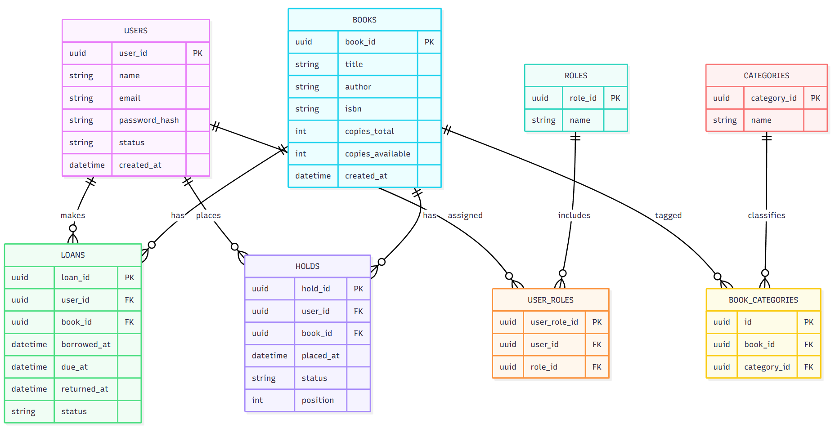

System Architecture Diagram
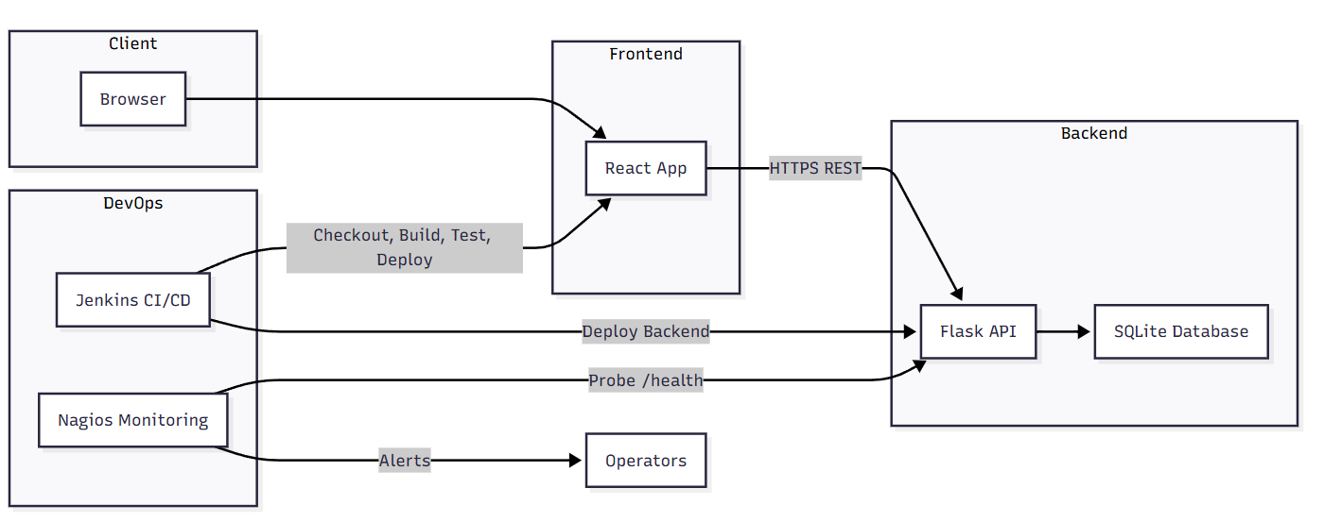

Use Case: Search Books

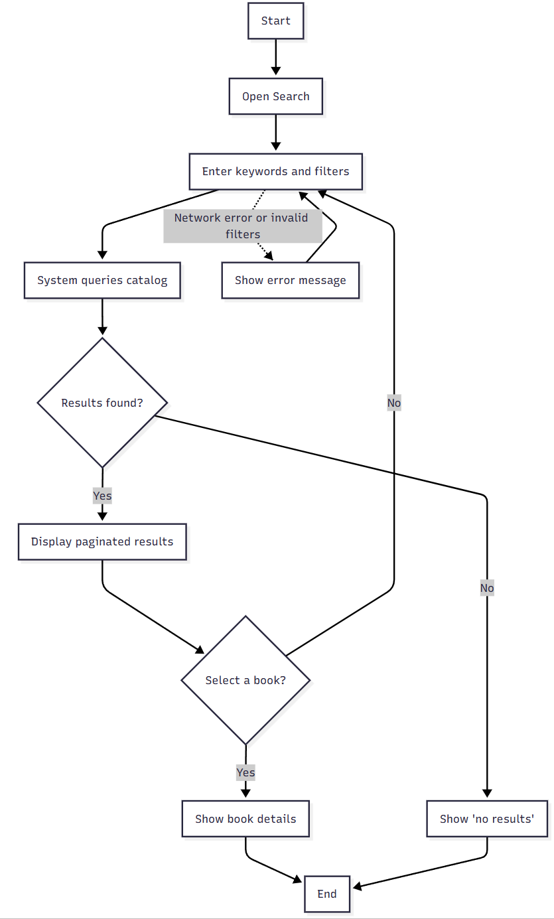

Use Case: Return a Book

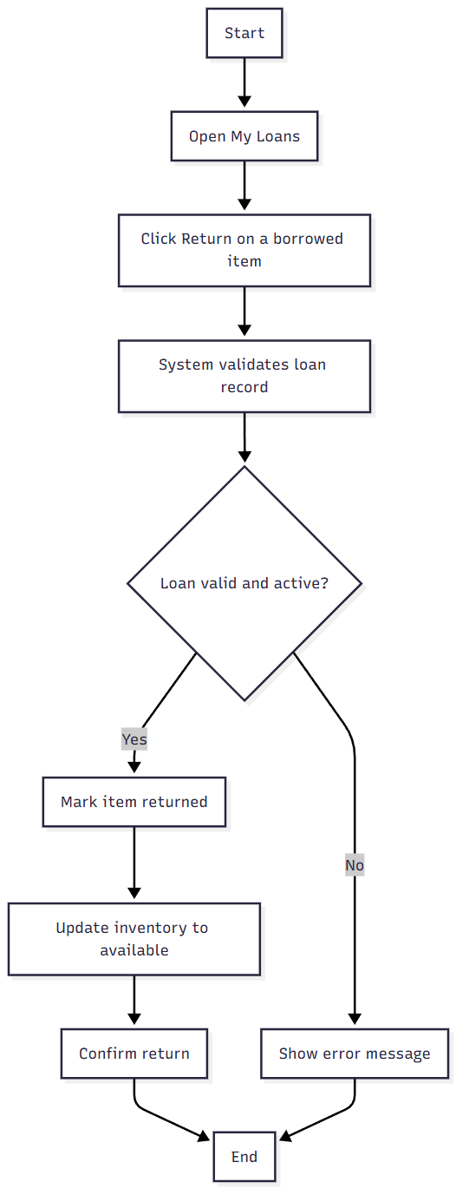

Use Case: Register & Login

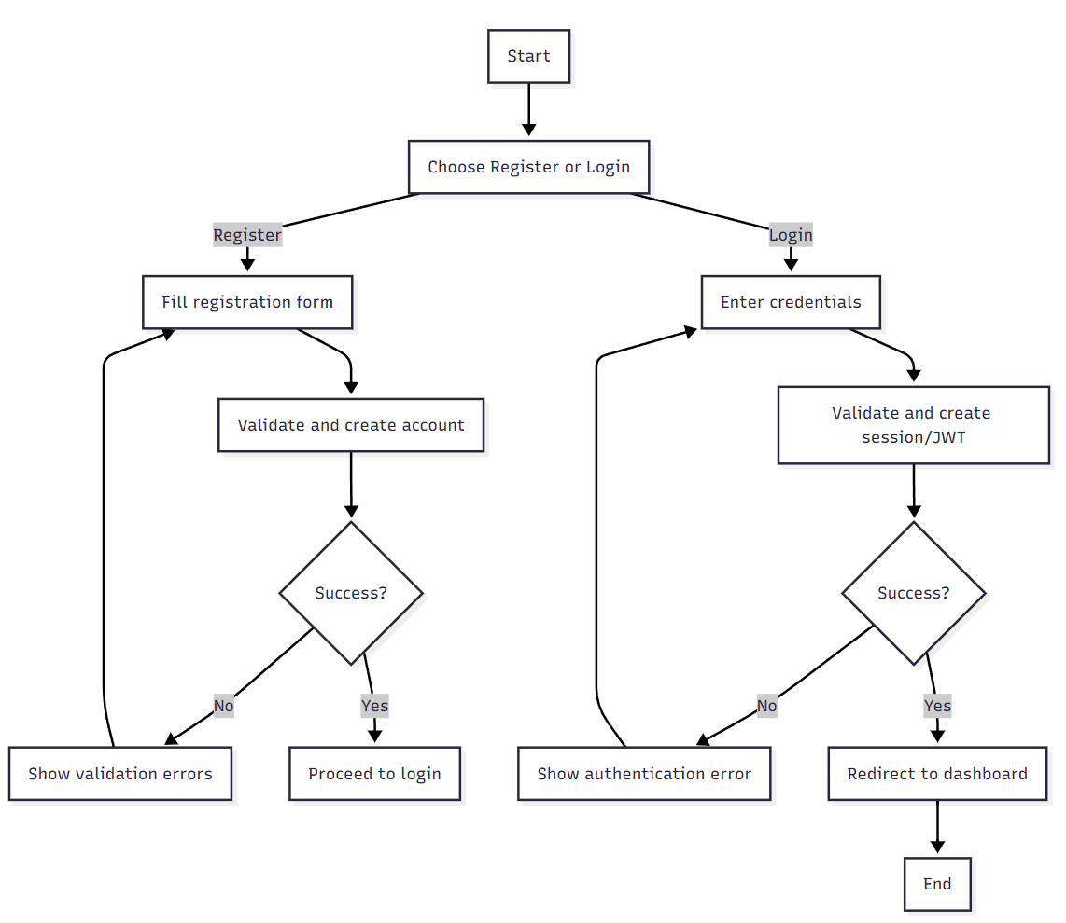

Use Case: Manage Users (Admin)
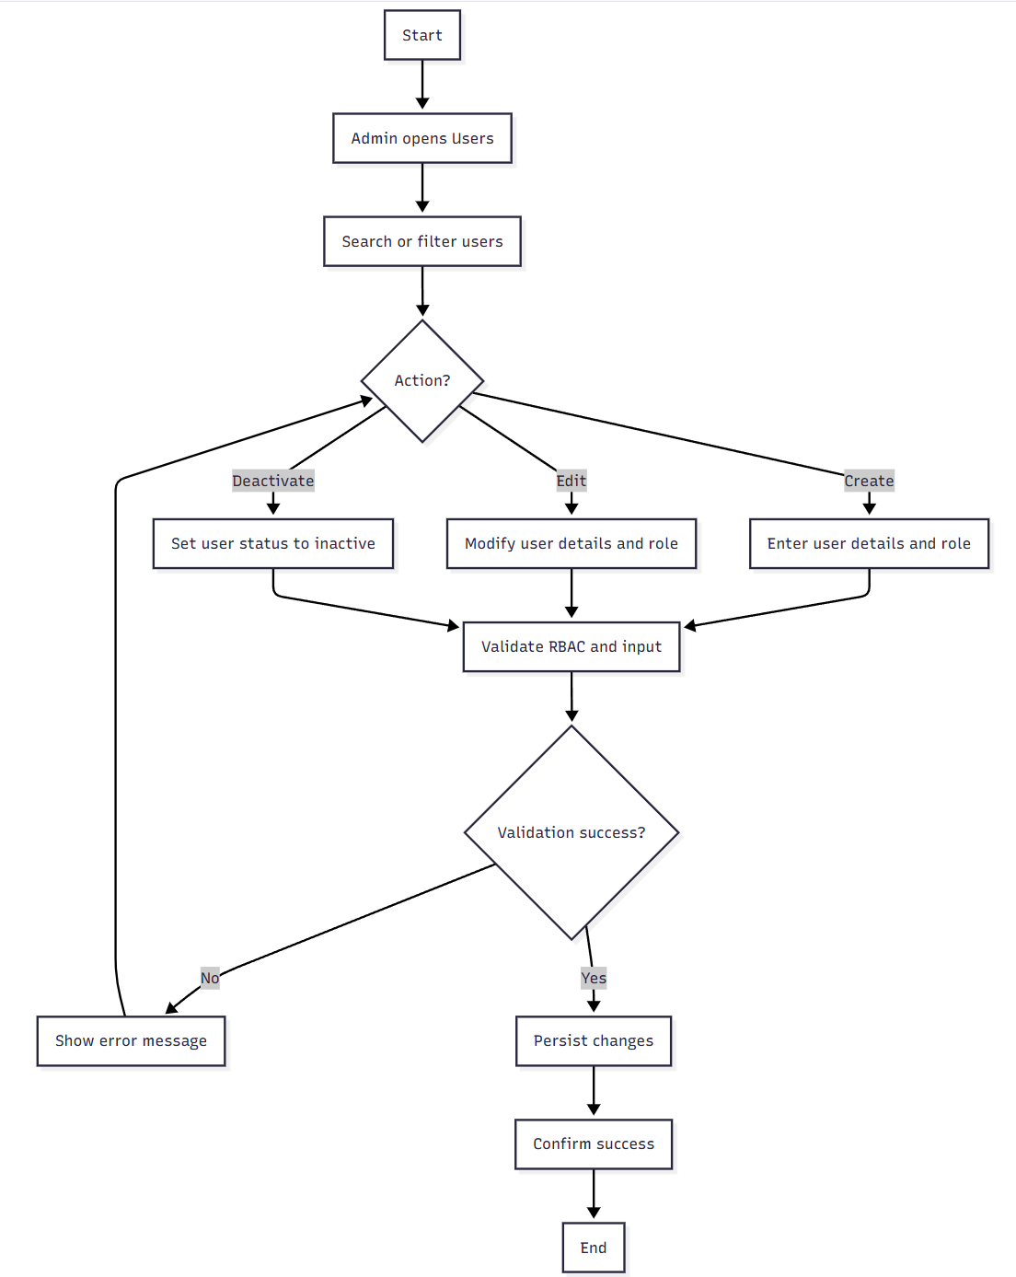

Use Case: Add/Update Book Metadata (Admin)
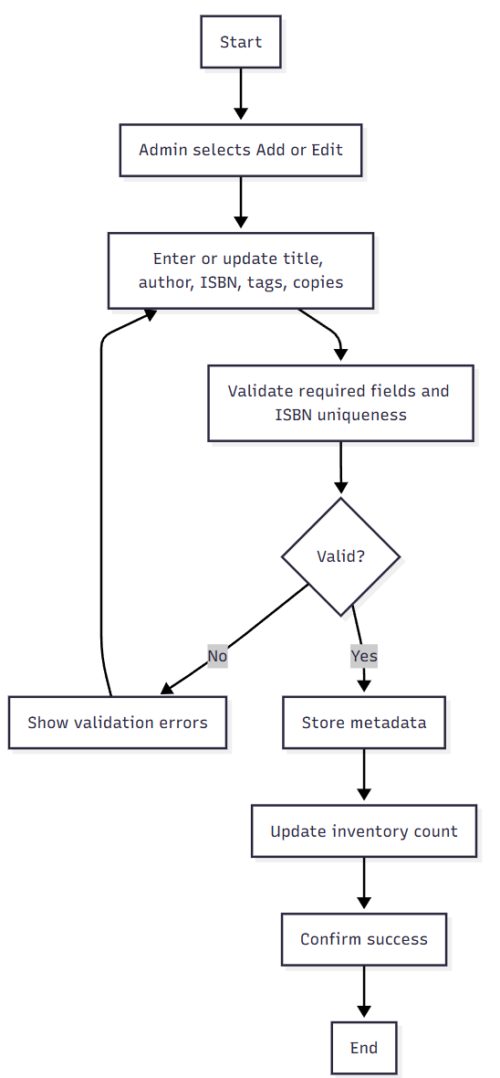

Use Case: Reserve / Place Hold
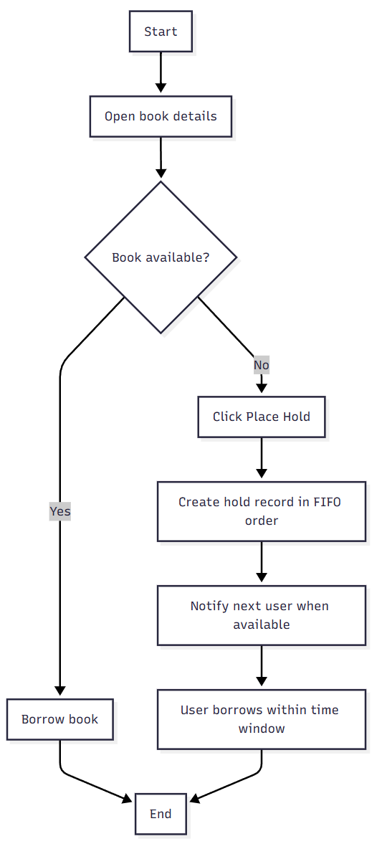

7. Use Cases

Use Case 1: Borrow a Book
Actors: Student, System
Preconditions: Student logged in
Trigger: Student selects a book to borrow
Steps:
1. Student searches and selects a book
2. System checks availability
3. Student confirms borrowing
4. System updates loan record
Postconditions: Book marked as borrowed
Exceptions: Book unavailable, network issues

Use Case 2: Add a New Book
Actors: Administrator, System
Preconditions: Administrator logged in
Trigger: Admin selects 'Add Book'
Steps:
1. Admin enters book details
2. System validates and stores information
Postconditions: Book added to database
Exceptions: Invalid input, DB error

Additional Use Cases

Use Case 3: Search Books
Actors: Student/Reader, System
Preconditions: User is logged in (or guest if allowed)
Trigger: User types keywords or filters
Main Flow:
1. User enters keywords and selects filters (category, author, availability)
2. System queries the catalog
3. System displays paginated results with availability and basic metadata
Postconditions: Results list displayed; search state retained for navigation
Exceptions: Network error; invalid filters

Use Case 4: Return a Book
Actors: Student/Reader, System
Preconditions: User has an active loan
Trigger: User clicks 'Return' on a borrowed item
Main Flow:
1. System validates the loan record and due date
2. System marks the item as returned and updates inventory
3. System calculates any fines (future) and closes the loan
Postconditions: Loan closed; book marked available
Exceptions: Loan not found; already returned; DB error

Use Case 5: Register & Login
Actors: User, System
Preconditions: System is reachable; registration open
Trigger: User selects 'Register' or 'Login'
Main Flow:
1. User fills registration form or enters credentials
2. System validates input and creates session/JWT
3. User redirected to dashboard
Postconditions: Authenticated session established
Exceptions: Weak password; duplicate email; invalid credentials

Use Case 6: Manage Users (Admin)
Actors: Administrator, System
Preconditions: Admin is authenticated with proper role
Trigger: Admin selects 'Users' from dashboard
Main Flow:
1. Admin searches/filters users
2. Admin creates/edits/deactivates users and assigns roles
3. System persists changes
Postconditions: User records updated; audit entry created (future)
Exceptions: Insufficient permissions; validation error

Use Case 7: Add/Update Book Metadata (Admin)
Actors: Administrator, System
Preconditions: Admin is authenticated
Trigger: Admin chooses 'Add Book' or 'Edit' on a title
Main Flow:
1. Admin enters/updates title, author, ISBN, tags, copies
2. System validates uniqueness (e.g., ISBN)
3. System stores metadata and updates inventory count
Postconditions: Catalog updated; book visible in searches
Exceptions: Duplicate ISBN; missing mandatory fields

Use Case 8: Reserve / Place Hold
Actors: Student/Reader, System
Preconditions: Book is currently unavailable
Trigger: User clicks 'Place Hold'
Main Flow:
1. System creates a hold record in FIFO order
2. When book is returned, system notifies next user (future email)
3. User has limited time window to borrow
Postconditions: Hold record created
Exceptions: User exceeds hold limit; book becomes available before hold completes

Use Case 9: CI/CD Deploy (DevOps)
Actors: [Member C] Jenkins, System
Preconditions: Repo has valid pipeline configuration
Trigger: Commit pushed to main/deploy branch
Main Flow:
1. Jenkins checks out code
2. Builds frontend and runs backend tests
3. Packages and deploys artifacts
4. Runs smoke tests on /health
Postconditions: New version deployed successfully
Exceptions: Build failure; smoke test fails; rollback triggered

Use Case 10: Health Check & Alerting (Monitoring)
Actors: [Member D] Nagios, System
Preconditions: Monitoring targets are registered
Trigger: Nagios scheduled check
Main Flow:
1. Nagios probes /health endpoint
2. If latency/high error rate, alert generated
3. Operator investigates and remediates
Postconditions: System health tracked; MTTR reduced
Exceptions: False positives; network partition

